1. Compiled and published project <https://github.com/chinadragon0515/Issue385/tree/master/WebApplication/RestierTestWebApplication> without any changes to local folder.

2. Copied published folder to the server and added to IIS, with the following config:

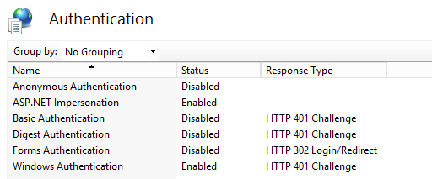

3. I select .NET 4.5 application pool, with run under special domain account (ask-ad\dynamic-service)

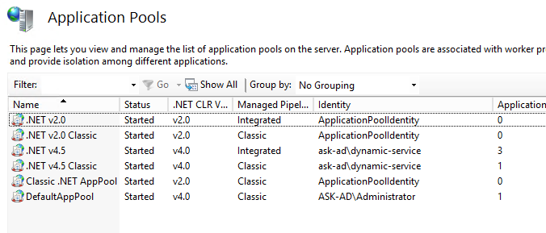

4. Added the following lines to Web.config:

<authentication mode="Windows"/>

<identity impersonate="true" />

5. Adjusted connection string to real DB

<add name="TestEntities" connectionString="metadata=res://*/Models.Model1.csdl|res://*/Models.Model1.ssdl|res://*/Models.Model1.msl;provider=System.Data.SqlClient;provider connection string=&quot;data source=192.168.100.174;initial catalog=B2MML-BatchML;integrated security=True;multipleactiveresultsets=True;application name=EntityFramework&quot;" providerName="System.Data.EntityClient" />

6. Open URL <http://localhost/RestierTestWebApplication/api/Test/v_System_User>

Browser asked to login and password, I entered own account credentials:

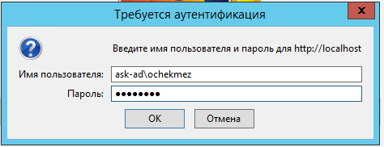

Result:

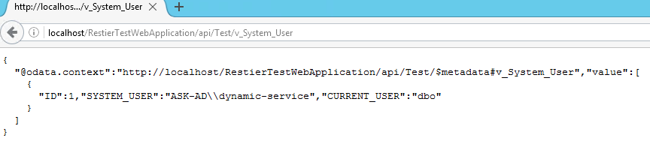

As you can see SYSTEM_USER is ask-ad\dynamic-service, not ask-ad\ochekmez